

<Auto ML Wireframes>

# User Manual

02/08/2024

Table of Contents

* **Introduction**
* **Installation**
* **Getting Started**
* **Data Ingestion**
* **Data Transformation**
* **Auto Train ML Models**
* **Freeze the Learnings**
* **Troubleshooting**

## Introduction

**Welcome to the AutoML Assistant user manual. This tool is engineered to streamline the process of building and deploying machine learning models. Designed for both novice and experienced data scientists, the AutoML Assistant offers an intuitive interface for managing data, transforming it for model training, and evaluating machine learning algorithms. With its user-friendly features, it simplifies complex tasks such as data ingestion, preprocessing, and model evaluation, making advanced machine learning accessible and efficient. This manual provides a comprehensive guide to using the tool, ensuring that you can maximize its capabilities and achieve your data science goals with ease.**

## Installation

**To begin using the AutoML Assistant, you need to install the application on your system. The installation process is straightforward and involves a few simple steps. First, ensure you have Python 3.6 or higher installed on your machine. Then, download the installation package from the official website or repository. Run the provided installer script or use pip to install the necessary dependencies. If you encounter any issues during installation, refer to the troubleshooting section of this manual for assistance. Once installed, launch the AutoML Assistant to start using its features. Ensure you have a stable internet connection for downloading additional libraries and updates**.

## Getting Started

**Getting started with the AutoML Assistant is simple and intuitive. After installation, open the application to access the main interface. The tool is organized into clearly defined sections: Data Ingestion, Data Transformation, Auto Train ML Models, and Freeze the Learnings. Begin by importing your dataset using the Data Ingestion feature. Once your data is loaded, proceed to the Data Transformation section to prepare it for model training. Configure your model parameters in the Auto Train ML Models section, and finally, use the Freeze the Learnings section to save and export your trained models. This streamlined process ensures that you can efficiently manage your machine learning tasks from start to finish.**

## Data Ingestion

**The Data Ingestion section is designed to facilitate the easy import of datasets into the AutoML Assistant. You can upload data files in CSV or Excel formats, providing flexibility depending on your data source. The tool allows you to either enter a file path manually or use the file uploader to select and load your data. Once the file is uploaded, a preview of the dataset is displayed, enabling you to confirm its accuracy before proceeding. This step is crucial as it ensures that the dataset is correctly formatted and ready for subsequent processing. The Data Ingestion feature helps you efficiently manage data input, laying the groundwork for effective data transformation and model training.**

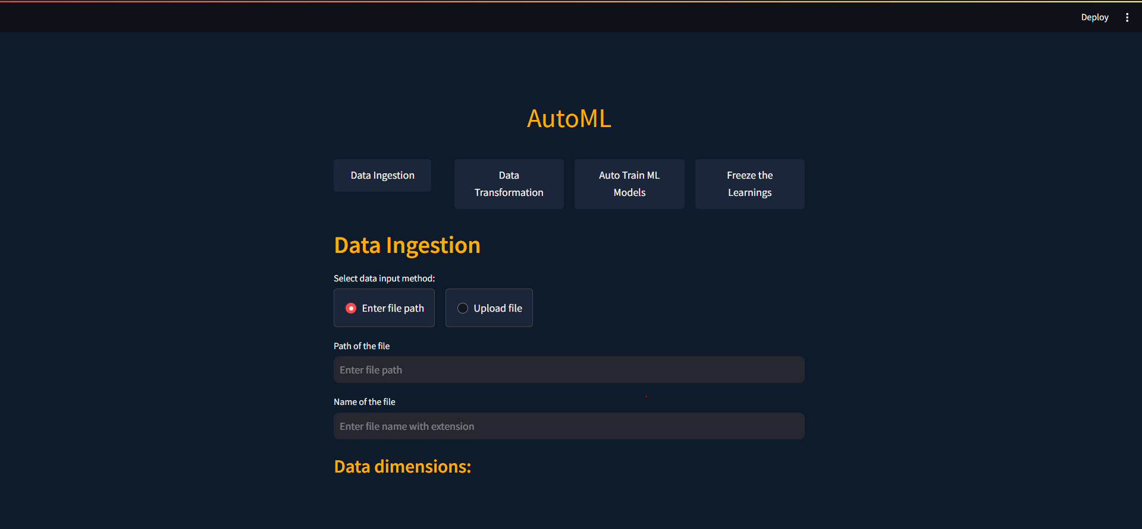

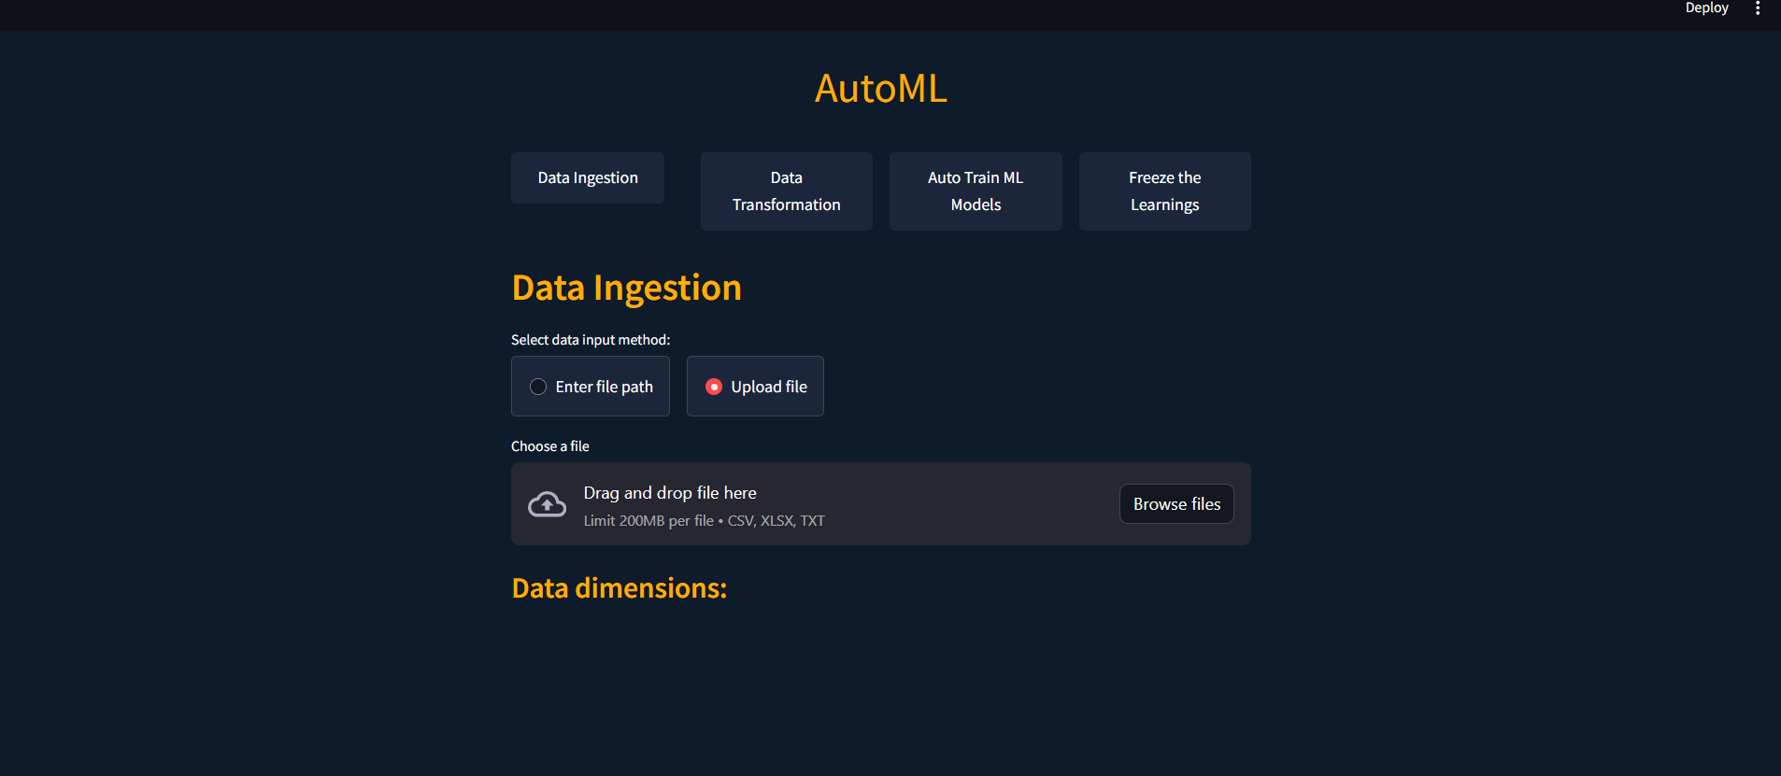

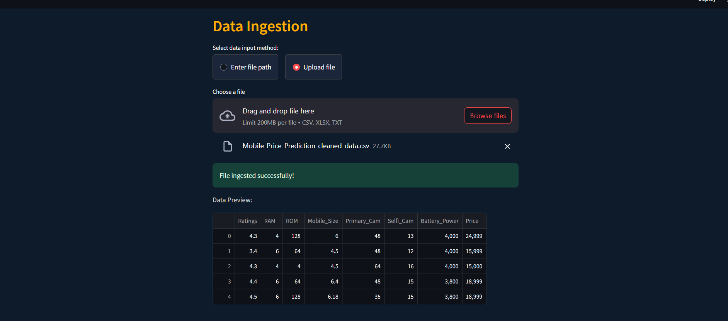

1. **Step-by-Step Guide to Using the Data Ingestion Interface in AutoML**
2. **Step 1: Accessing the Data Ingestion Page**

When you first open the AutoML interface, you will see a screen with four main options:

1. Data Ingestion
2. Data Transformation
3. Auto Train ML Models
4. Freeze the Learnings

To start, click on "Data Ingestion."

1. **Step 2: Selecting Data Input Method**

On the Data Ingestion page, you will be prompted to select a data input method. You have two options:

* Enter file path
* Upload file

Choose one based on your preference. If you choose "Enter file path," you will need to type the path of your data file. If you choose "Upload file," you will be able to browse and select a file from your computer.

1. **Step 3: Uploading a File**

If you selected "Upload file," click on the "Browse files" button. This will open a file dialog box where you can navigate to the location of your data file. You can also drag and drop the file into the designated area. The supported file formats are CSV, XLSX, and TXT with a size limit of 200MB per file.

1. **Step 4: Confirming File Upload**

Once the file is uploaded, the interface will display a message indicating that the file was ingested successfully. A preview of the dataset will also be shown, allowing you to verify the contents. This preview helps you ensure that the dataset is correctly formatted and ready for further processing.

1. **Step 5: Reviewing Data Preview**

The data preview section shows a small portion of your dataset, including column headers and some sample rows. Check this preview to confirm that the data has been ingested correctly. This step is crucial for identifying any potential issues with the dataset before moving on to data transformation and model training.

By following these steps, you can efficiently manage data input using the AutoML interface, setting the stage for effective data transformation and model training.

## 5.Data Transformation

**Data Transformation is a vital step in preparing your dataset for machine learning model training. This section offers tools for cleaning and preprocessing your data, including handling missing values, removing duplicates, and converting categorical features into numeric formats. You can select specific columns to modify, apply transformations such as filling missing values with mean, median, or mode, and drop irrelevant features. The Data Transformation section ensures that your dataset is compatible with machine learning algorithms, improving the quality and performance of your models. By providing these capabilities, the tool streamlines data preparation, allowing you to focus on model development and analysis.**

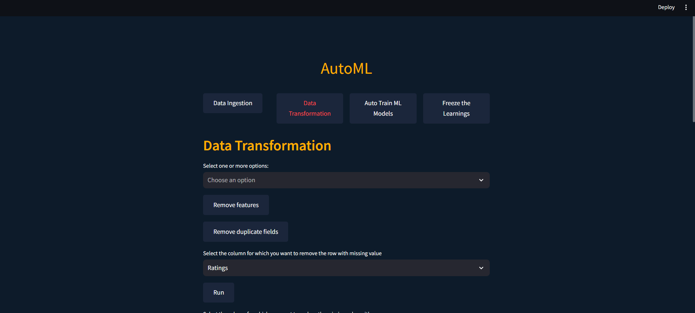

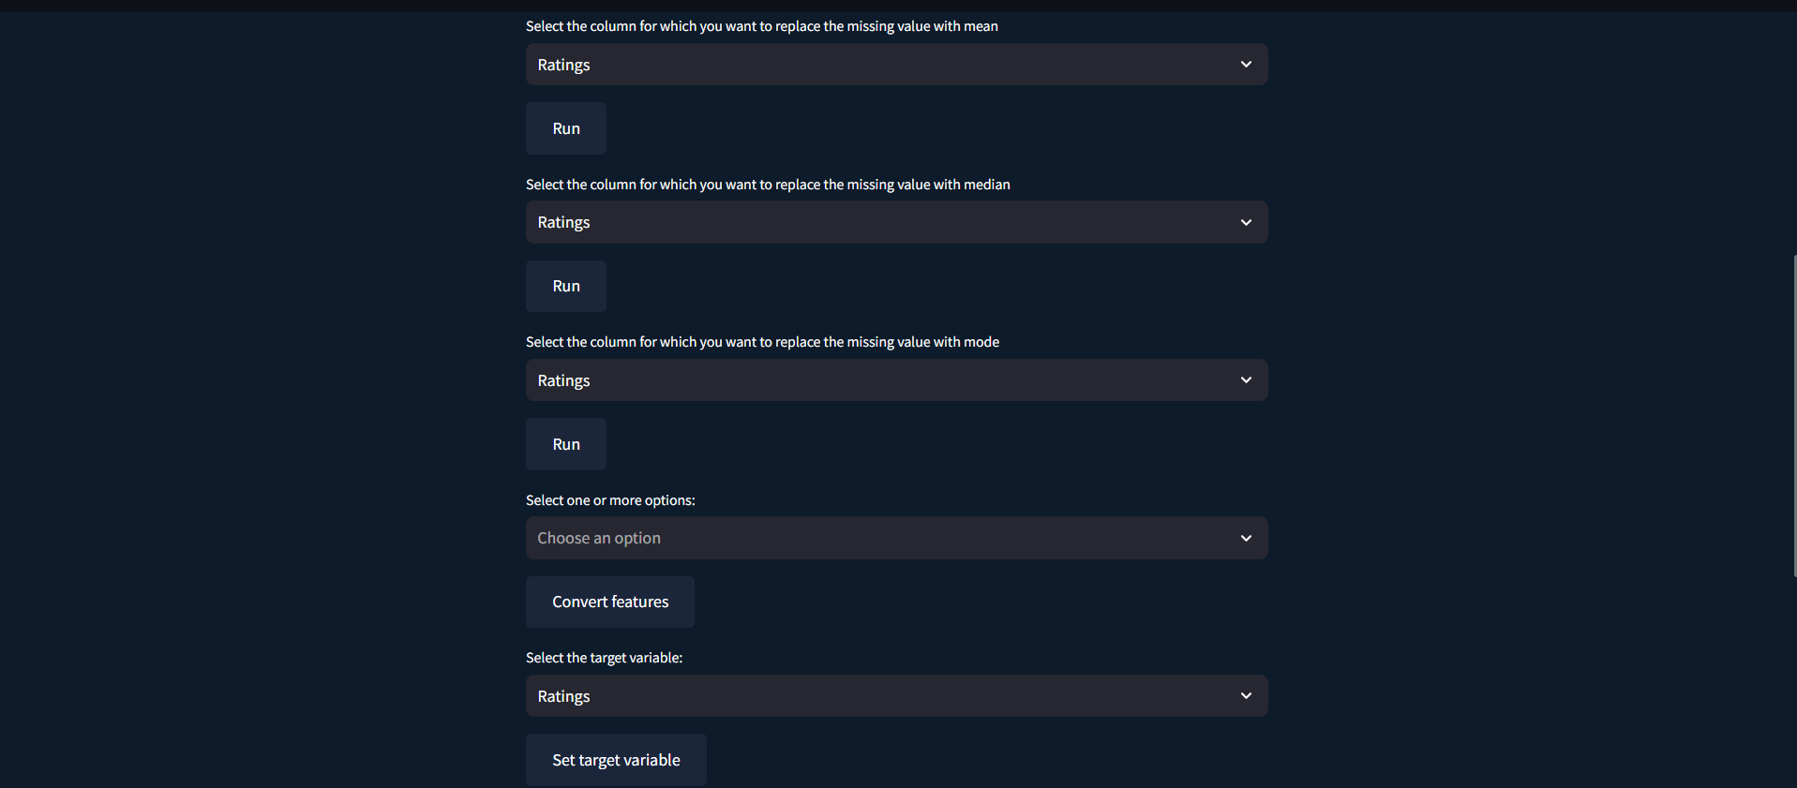

1. **Step 1: Accessing the Data Transformation Page**

Once you have successfully ingested your data, the next step is data transformation. Start by clicking on the "Data Transformation" button on the main AutoML interface.

1. **Step 2: Viewing the Data Transformation Options**

On the Data Transformation page, you will find several options for cleaning and preprocessing your data. These options typically include:

* Handling missing values
* Removing duplicates
* Converting categorical features into numeric formats
* Selecting specific columns to modify
* Dropping irrelevant features

Take a moment to familiarize yourself with these options as they are crucial for preparing your dataset.

1. **Step 3: Selecting Columns for Transformation**

Choose the columns that you want to transform. This step is important because it allows you to focus on the features that are relevant to your machine learning model. You can typically do this by checking boxes next to the column names or using a selection tool provided in the interface.

1. **Step 4: Handling Missing Values**

The interface will offer several methods for handling missing values in your dataset. Common options include:

* Filling missing values with the mean, median, or mode of the column
* Dropping rows with missing values
* Interpolating missing values based on other data points

Select the appropriate method for each column with missing data. This step ensures that your dataset is complete and ready for model training.

1. **Step 5: Removing Duplicates**

Use the tool to identify and remove duplicate rows from your dataset. Duplicates can skew the results of your machine learning model, so it's important to address them during data transformation.

1. **Step 6: Converting Categorical Features**

If your dataset contains categorical features (non-numeric data), you will need to convert them into numeric formats. The interface will provide options such as one-hot encoding or label encoding to transform these features. Choose the method that best suits your dataset and machine learning model requirements.

1. **Step 7: Dropping Irrelevant Features**

Identify and drop any columns that are not relevant to your analysis or model training. This step helps to streamline your dataset, removing unnecessary data that could affect model performance.

1. **Step 8: Applying Transformations**

After selecting the appropriate transformations, apply them to your dataset. The interface will typically have an "Apply" or "Transform" button to execute these changes.

1. **Step 9: Reviewing Transformed Data**

Once the transformations are applied, review the updated dataset to ensure that all changes were implemented correctly. This final check helps to confirm that your data is now clean, complete, and ready for machine learning model training.

## Auto Train ML Models

**The Auto Train ML Models section is where the core machine learning tasks are performed. Here, you can select from a variety of popular algorithms, including Support Vector Machines (SVM), Random Forests, and more. The tool guides you through configuring model parameters, splitting your data into training and testing sets, and training the models. Performance metrics such as accuracy, R^2 score, and RMSE are calculated to evaluate model performance. This section provides an automated approach to model training, enabling you to quickly test and compare different algorithms and parameters. The goal is to identify the best-performing model with minimal manual intervention, streamlining the machine learning process.**

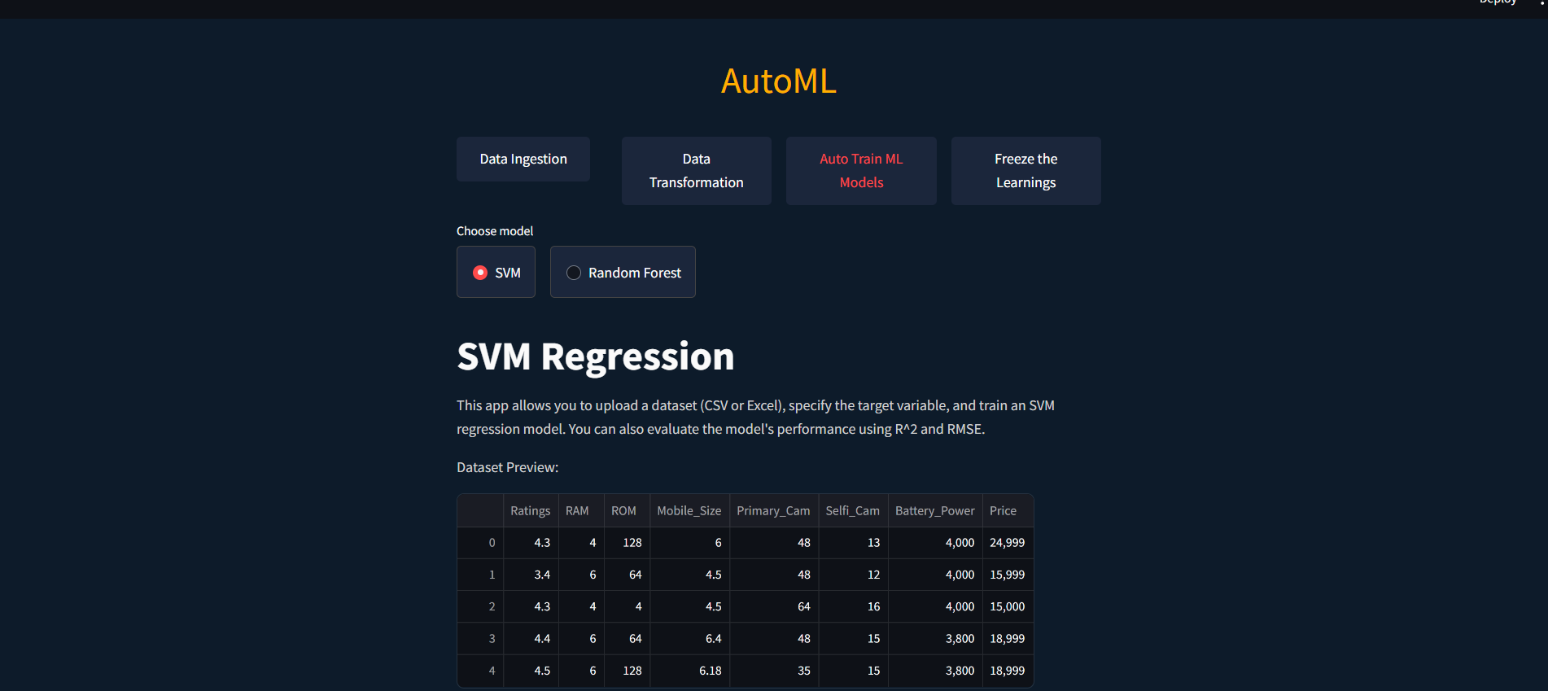

1. **Step 1: Accessing the Auto Train ML Models Page**

Once you have completed data ingestion and transformation, the next step is to train your machine learning models. Start by clicking on the "Auto Train ML Models" button on the main AutoML interface.

1. **Step 2: Selecting an Algorithm**

On the Auto Train ML Models page, you will find options to select from a variety of popular machine learning algorithms. Common choices include:

* Support Vector Machines (SVM)
* Random Forests
* Decision Trees
* Linear Regression
* K-Nearest Neighbors (KNN)
* Neural Networks

Choose the algorithm that you want to use for training your model.

1. **Step 3: Configuring Model Parameters**

After selecting an algorithm, the interface will guide you through configuring the model parameters. This may include setting hyperparameters such as the number of trees for Random Forests, kernel type for SVM, or learning rate for Neural Networks. Adjust these parameters based on your understanding of the algorithm and the specifics of your dataset.

1. **Step 4: Splitting Data into Training and Testing Sets**

The tool will prompt you to split your dataset into training and testing sets. This step is crucial for evaluating model performance. You can typically specify the proportion of the data to be used for training versus testing (e.g., 80% training and 20% testing). The tool may offer default settings or allow you to customize the split ratio.

1. **Step 5: Training the Models**

Click the button to start training the models. The interface will automatically handle the training process, applying the selected algorithm and parameters to your training data. This automated approach saves time and minimizes the need for manual intervention.

1. **Step 6: Evaluating Model Performance**

Once the training is complete, the tool will calculate and display performance metrics to evaluate the model. Common metrics include:

* Accuracy: The proportion of correctly predicted instances out of the total instances.
* R^2 Score: A statistical measure that indicates how well the model's predictions approximate the actual data.
* Root Mean Squared Error (RMSE): A measure of the differences between predicted and actual values.

Review these metrics to assess the performance of your model.

1. **Step 7: Comparing Different Algorithms and Parameters**

You can repeat the training process with different algorithms and parameter settings to compare their performance. This iterative process helps you identify the best-performing model for your dataset. The interface may provide a summary or comparison chart to help you make an informed decision.

1. **Step 8: Selecting the Best Model**

Based on the performance metrics, select the best-performing model. This model will be the one you proceed with for deployment or further analysis.

By following these steps, you can effectively use the Auto Train ML Models interface in AutoML to train, evaluate, and compare different machine learning models. This section provides an automated and streamlined approach to model training, helping you quickly identify the optimal model for your dataset.

## Freeze the Learnings

**The Freeze the Learnings section allows you to save and export your trained models for future use. Once a model has been trained and evaluated, you can generate a pickled file of the model, which can be easily integrated into other applications or workflows. This feature supports saving models in a format that preserves their state and performance characteristics, ensuring consistency and reliability when deploying or sharing the model. Whether you want to archive a model for future analysis or deploy it in a production environment, this section provides a straightforward way to manage and utilize your machine learning assets.**

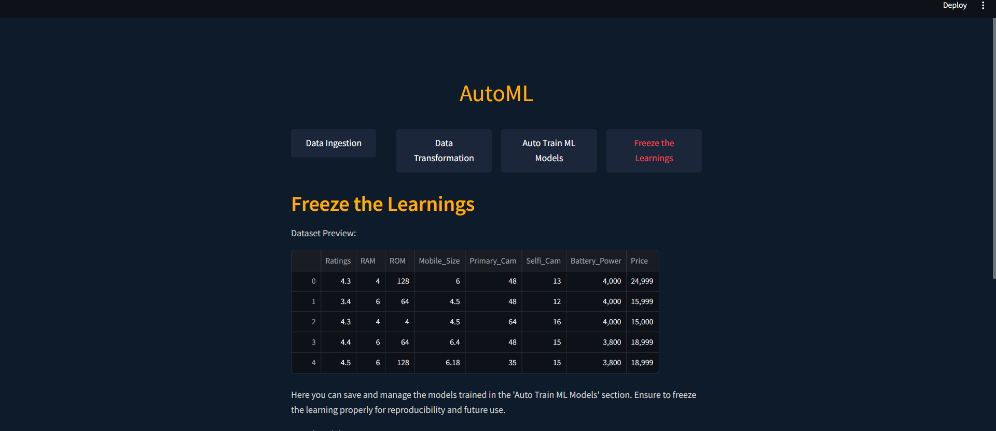

1. **Step 1: Accessing the Freeze the Learnings Page**

After completing data ingestion, transformation, and training your machine learning models, the final step is to save and export your trained models. Start by clicking on the "Freeze the Learnings" button on the main AutoML interface.

1. **Step 2: Viewing the Freeze the Learnings Options**

On the Freeze the Learnings page, you will find options to save and export your trained models. This section provides a way to preserve the state and performance of your models by generating pickled files.

1. **Step 3: Selecting a Model to Save**

If you have trained multiple models, you will need to select the specific model you want to save. This selection can usually be done via a dropdown menu or a list of available models. Choose the model that you wish to preserve.

1. **Step 4: Generating the Pickled File**

Click on the button or link provided to generate the pickled file for your selected model. The interface will typically prompt you to specify a location to save the file on your computer or within the application’s storage system.

1. **Step 5: Exporting the Model**

Once the pickled file is generated, you will have the option to export it. This step allows you to download the file and integrate it into other applications or workflows. The exported model file can be easily shared or deployed in a production environment, ensuring consistency and reliability in its performance.

1. **Step 6: Verifying the Exported Model**

After exporting the model, it is a good practice to verify that the file has been correctly saved and is functional. You can do this by loading the pickled file in a separate environment and testing it with a sample input to ensure it produces the expected output.

By following these steps, you can effectively use the Freeze the Learnings interface in AutoML to save and export your trained models, ensuring they are ready for future use or deployment. This feature helps you manage your machine learning assets efficiently, providing a straightforward way to preserve and utilize your work.

## 8.Troubleshooting

**The Troubleshooting section offers solutions to common problems users may encounter while using the AutoML Assistant. It includes detailed instructions for resolving issues related to data ingestion, model training, and application performance. Common problems such as file format errors, missing dependencies, and performance issues are addressed with step-by-step solutions. This section is designed to help users quickly identify and resolve issues, ensuring a smooth and uninterrupted experience with the tool. If you are unable to resolve an issue using this guide, please contact our support team for personalized assistance.**

1. **Step 1: Accessing the Troubleshooting Section**

If you encounter any issues while using the AutoML Assistant, navigate to the Troubleshooting section by clicking on the appropriate button or link in the main interface. This section is designed to help you resolve common problems quickly and efficiently.

1. **Step 2: Identifying the Problem**

Start by identifying the category of your issue. The Troubleshooting section is typically organized into different categories such as:

* Data Ingestion Issues
* Model Training Issues
* Application Performance Issues

Select the category that best matches the problem you are experiencing.

1. **Step 3: Resolving Data Ingestion Issues**

If you are facing problems related to data ingestion, look for solutions under the Data Ingestion Issues category. Common problems and their solutions may include:

* File Format Errors: Ensure that your data file is in a supported format (CSV, XLSX, TXT) and within the size limit. If you receive a file format error, convert your file to a compatible format and try again.
* Path Errors: Double-check the file path entered if you are using the "Enter file path" method. Ensure that the path is correct and the file is accessible.
* Upload Errors: If you encounter issues while uploading a file, ensure that your internet connection is stable and the file size does not exceed the limit.

1. **Step 4: Resolving Model Training Issues**

For issues related to model training, refer to the Model Training Issues category. Common problems and their solutions may include:

* Missing Dependencies: Ensure that all required libraries and dependencies are installed. The troubleshooting guide will provide instructions on how to install missing dependencies.
* Parameter Errors: Review the parameters set for your model. Incorrect or incompatible parameter settings can cause training failures. Adjust the parameters and try training the model again.
* Data Split Issues: Verify that your data is correctly split into training and testing sets. An improper split ratio can lead to skewed results and performance metrics.

1. **Step 5: Resolving Application Performance Issues**

If the application is running slowly or experiencing performance issues, check the Application Performance Issues category. Common problems and their solutions may include:

* High Memory Usage: Large datasets or complex models can consume a lot of memory. Consider reducing the dataset size or simplifying the model to improve performance.
* Slow Processing: Ensure that your system meets the recommended hardware requirements for running the AutoML Assistant. Upgrading your hardware or optimizing your system settings may help.
* Application Crashes: If the application crashes frequently, look for software updates or patches that address known issues. Reinstalling the application may also resolve the problem.

1. **Step 6: Following Step-by-Step Solutions**

Each problem in the Troubleshooting section will come with detailed step-by-step solutions. Follow these instructions carefully to resolve your issue. If the problem persists, try alternative solutions provided in the guide.